**RATIO ANALYSIS PROBLEMS**

**Problem 1: From the following information, calculate Liquidity Ratios.**

**Balance Sheet of XYZ Co. Ltd., as on 31.12.2000**

|  |  |  |  |
| --- | --- | --- | --- |
| **Liabilities** | **Amount (Rs.)** | **Assets** | **Amount (Rs.)** |
| Preference Share Capital | 100 | Land and Buildings | 225 |
| Equity Share Capital | 150 | Plant and Machinery | 250 |
| General Reserves | 250 | Furniture and Fixtures | 100 |
| Debentures | 400 | Stock | 250 |
| Creditors | 200 | Debtors | 125 |
| Bills Payable | 50 | Cash at Bank | 250 |
| Outstanding expenses | 50 | Cash in Hand | 125 |
| Profit and Loss A/C | 100 | Prepaid expenses | 50 |
| Bank Loan (Long-term) | 200 | Marketable securities | 125 |
|  |  |  |  |
| Total | 1500 |  | 1500 |

**Current Ratio = 925 / 300 = 3.08:1**

**Quick Ratio : 925 – (250+50) = 625**

**625 / 300 = 2.08:1**

**2. Problem 2:**

**From the Following Balance Sheet of a company as on 31st March:**

**[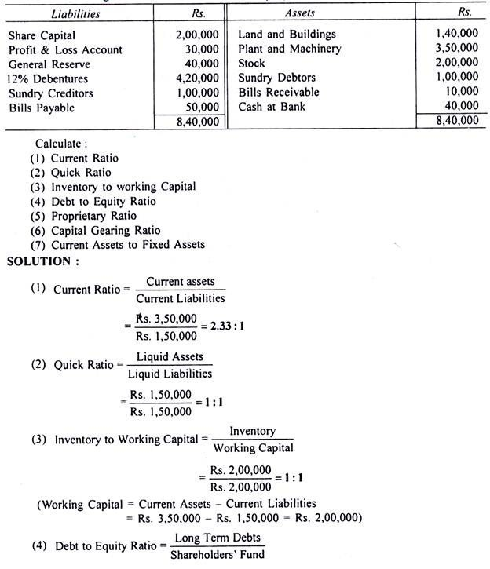](http://cdn.accountingnotes.net/wp-content/uploads/2017/01/clip_image001.jpg)**

**[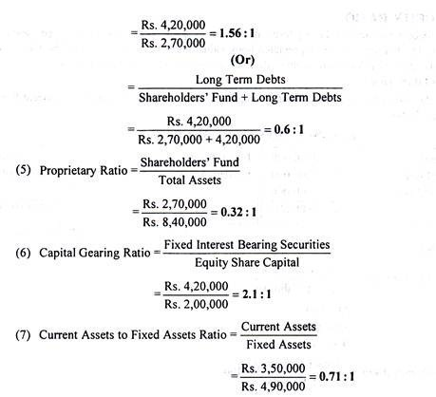](http://cdn.accountingnotes.net/wp-content/uploads/2017/01/clip_image002-1.jpg)**

**Problem 2:**

**From the following particulars found in the Trading, Profit and Loss Account of A Company Ltd., work out the operation ratio of the business concern:**

**[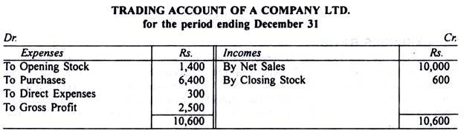](http://cdn.accountingnotes.net/wp-content/uploads/2017/01/clip_image003.jpg)**

**Problem 3:**

**The following is the summarised Profit and Loss Account of Taj Products Ltd. for the year ended 31st December:**

**[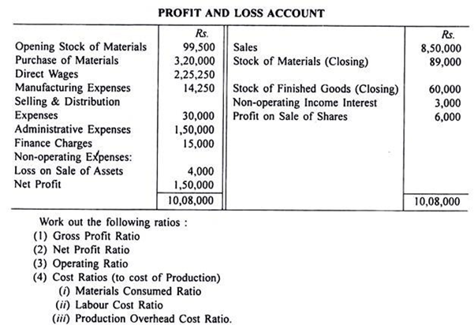](http://cdn.accountingnotes.net/wp-content/uploads/2017/01/clip_image005.png)**

**[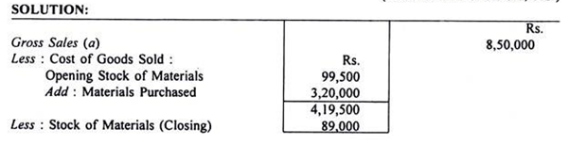](http://cdn.accountingnotes.net/wp-content/uploads/2017/01/clip_image006.png)**

**[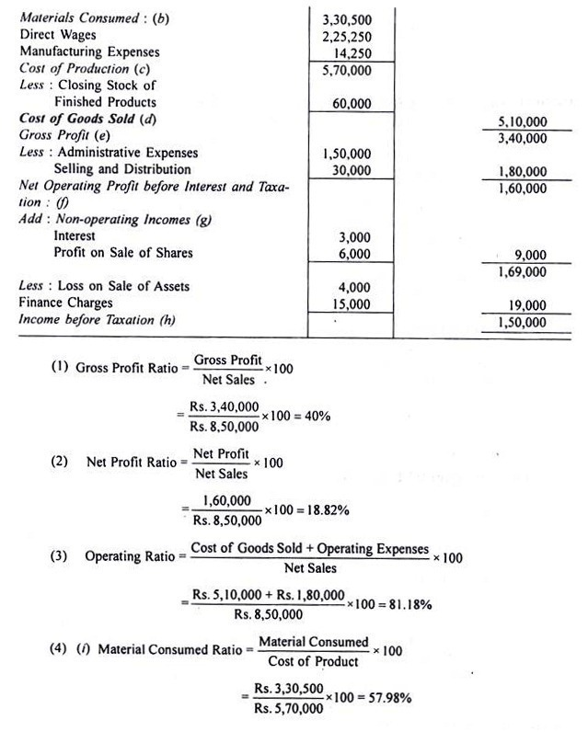](http://cdn.accountingnotes.net/wp-content/uploads/2017/01/clip_image007.jpg)**

**[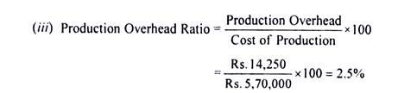](http://cdn.accountingnotes.net/wp-content/uploads/2017/01/clip_image008-1.jpg)**

**Problem 4:**

**From the following Balance Sheet and additional information, you are required to calculate:**

(i) Return on Total Resources

(ii) Return on Capital Employed

(iii) Return on Shareholders’ Fund

**[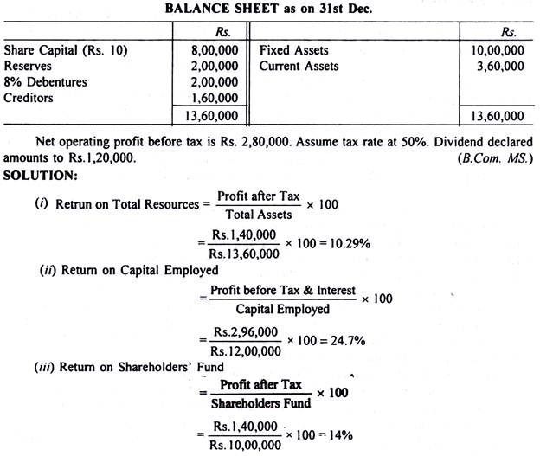](http://cdn.accountingnotes.net/wp-content/uploads/2017/01/clip_image009.jpg)**

**Problem 5:**

A company has capital of Rs. 10, 00,000; its turnover is 3 times the capital and the margin on sales is 6%. What is the return on investment.

**[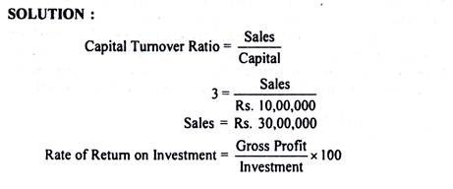](http://cdn.accountingnotes.net/wp-content/uploads/2017/01/clip_image010-1.jpg)**

**[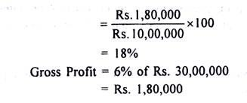](http://cdn.accountingnotes.net/wp-content/uploads/2017/01/clip_image011.jpg)**

**Problem 6:**

**Ram & Company supplies you the following information regarding the year ended 31st December:**

**[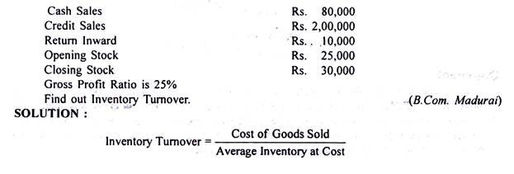](http://cdn.accountingnotes.net/wp-content/uploads/2017/01/clip_image012-3.jpg)**

**[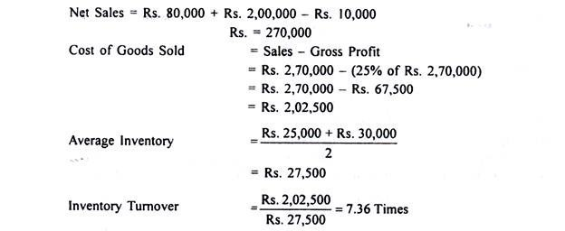](http://cdn.accountingnotes.net/wp-content/uploads/2017/01/clip_image013.jpg)**

**Significance:**

A high Inventory turnover ratio is better than a low ratio. A high ratio implies good inventory ‘management and an indication of under-investment. It will adversely affect the ability of a firm to meet customers’ demand. At the same time, a higher ratio reflects efficient business activities.

A low inventory turnover ratio is dangerous. It is an indication of excessive inventory and over investment in inventory. A low ratio may be result of inferior quality goods, stock of un-saleable and absolute goods. A lower ratio reflects dull business and suggests that some steps should be taken to push up sales.

**Problem 7:**

**The following is the Profit and Loss Account of Burn Ltd.**

**[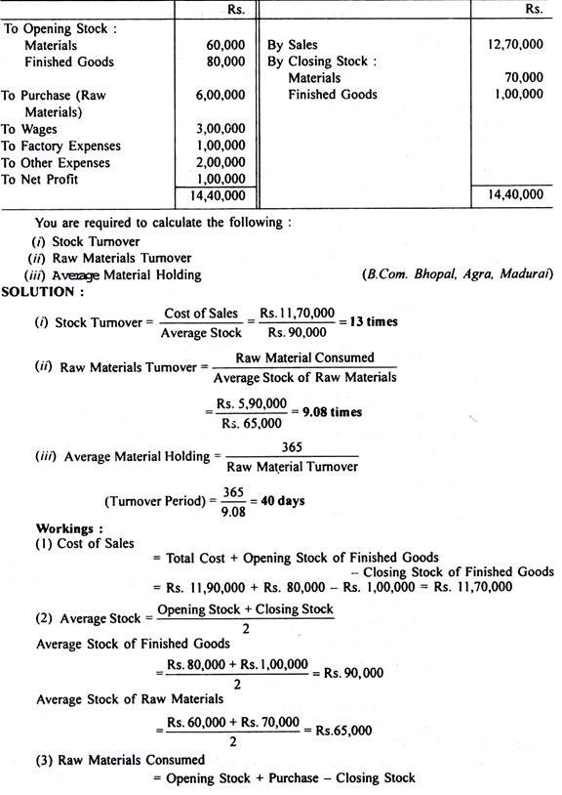](http://cdn.accountingnotes.net/wp-content/uploads/2017/01/clip_image014-2.jpg)**

= Rs. 60,000 + Rs. 6, 00,000

= Rs. 5, 90,000

**Problem 8:**

**Calculate Debtors Velocity from the following details:**

Opening Balance of Debtors Rs. 10,000

Credit Sales during the year Rs. 20,000

Sales Returns Rs. 1,000

Discount on Sales Rs. 50

Cash collected from Debtors during the year Rs, 5,000

Bad Debts Rs. 500

Bad Debt Provision at 10%

**[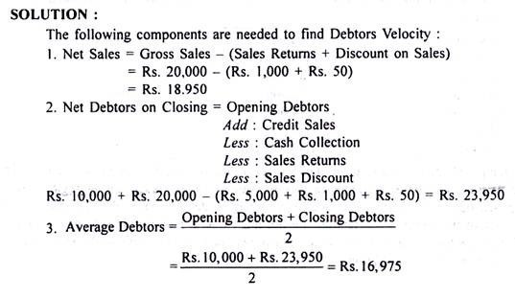](http://cdn.accountingnotes.net/wp-content/uploads/2017/01/clip_image015.jpg)**

**[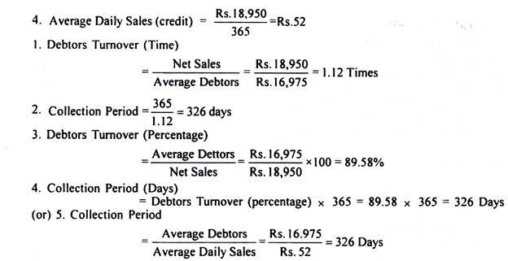](http://cdn.accountingnotes.net/wp-content/uploads/2017/01/clip_image016-2.jpg)**

**Note:**

Bills Receivable from the buyer of fixed assets, should be excluded.

Bad and doubtful debts and their provisions are not deducted from the total debtors in order to avoid the impression that a larger amount of receivables have been collected.

**Significance:**

A turnover ratio of 8 signifies that debtors get converted into cash 8 times in a year. The average collection period of 1.5 months implies that debtors are collected in 45 days. The average collection period ratio measures the quality of debtors since it indicates the rapidity or slowness of their collectability. The shorter the average collection period, the better the quality of debtors.

The higher the Turnover Ratio and the shorter the average collection period, the better the trade credit management and the better the liquidity of debtors. That is, high Turnover Ratio and short collection period imply prompt payment on the part of debtors. On the other hand, low Turnover Ratio and long collection period reflects that payments by debtors are delayed.

**Problem 9:**

**The Capital of a Company is as follows:**

**[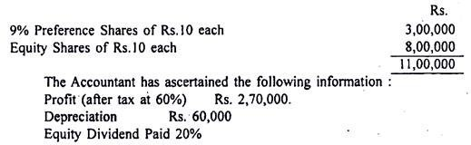](http://cdn.accountingnotes.net/wp-content/uploads/2017/01/clip_image017.jpg)**

**[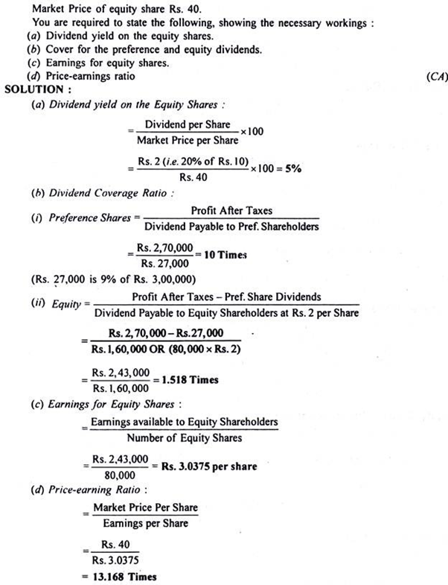](http://cdn.accountingnotes.net/wp-content/uploads/2017/01/clip_image018.png)**

**Problem 10:**

**Assume that a firm has owners’ equity of Rs. 1, 00,000. The ratios for the firm are:**

**[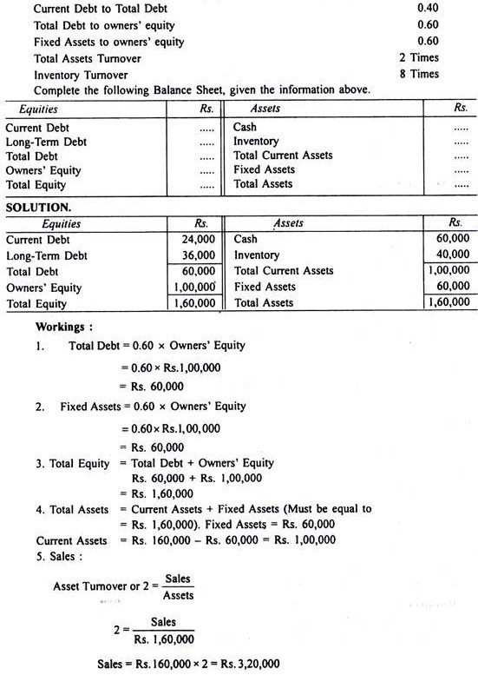](http://cdn.accountingnotes.net/wp-content/uploads/2017/01/clip_image019.jpg)**

**[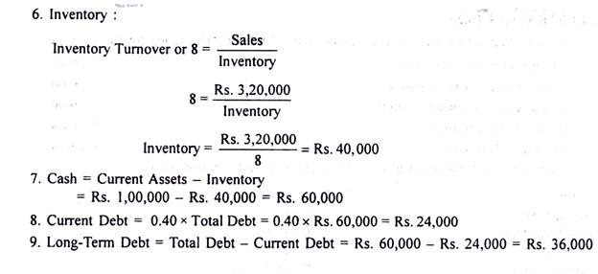](http://cdn.accountingnotes.net/wp-content/uploads/2017/01/clip_image020-1.jpg)**

**Problem 11:**

**With the following ratios and further information given below, prepare a Trading, Profit and Loss Account and Balance Sheet:**

**[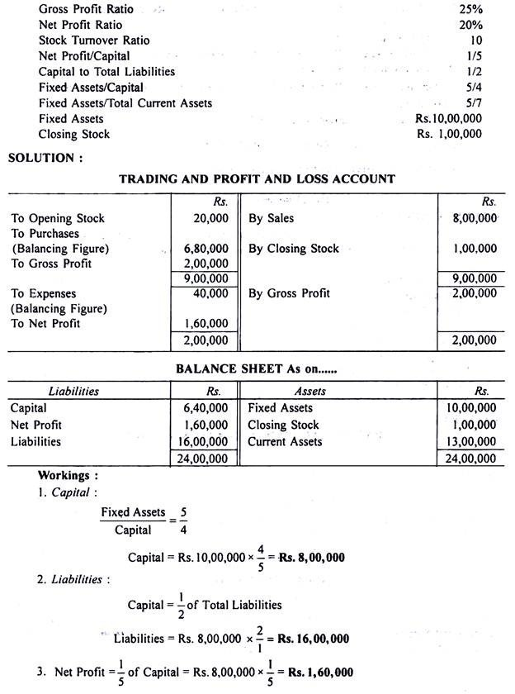](http://cdn.accountingnotes.net/wp-content/uploads/2017/01/clip_image021.jpg)**

**[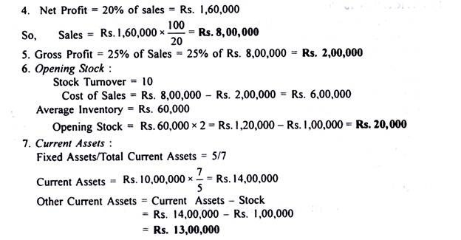](http://cdn.accountingnotes.net/wp-content/uploads/2017/01/clip_image022-1.jpg)**

**Problem 12:**

**Extract from financial accounts of X, Y, Z Ltd. are:**

**[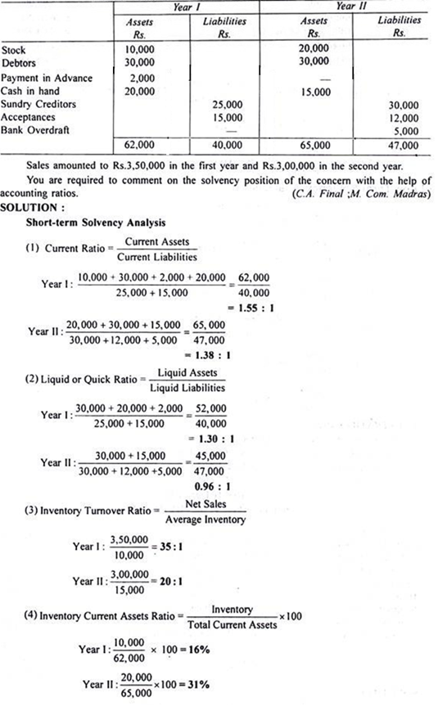](http://cdn.accountingnotes.net/wp-content/uploads/2017/01/clip_image023.png)**

**[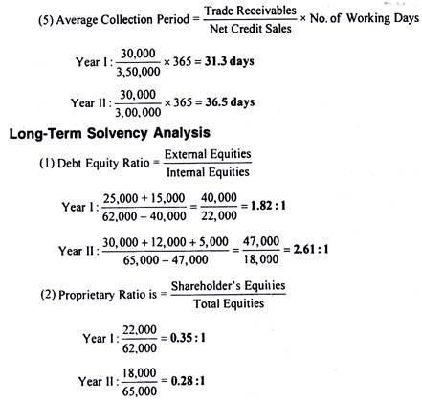](http://cdn.accountingnotes.net/wp-content/uploads/2017/01/clip_image024-1.jpg)**

**Problem 13:**

**Following is the summarised Balance Sheet of a concern as at 31st December:**

**[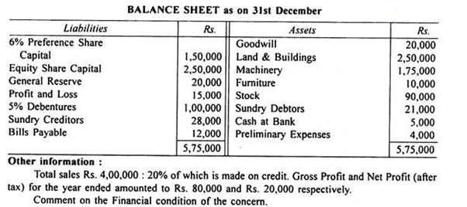](http://cdn.accountingnotes.net/wp-content/uploads/2017/01/clip_image025.png)**

**[](http://cdn.accountingnotes.net/wp-content/uploads/2017/01/clip_image026.png)**

**[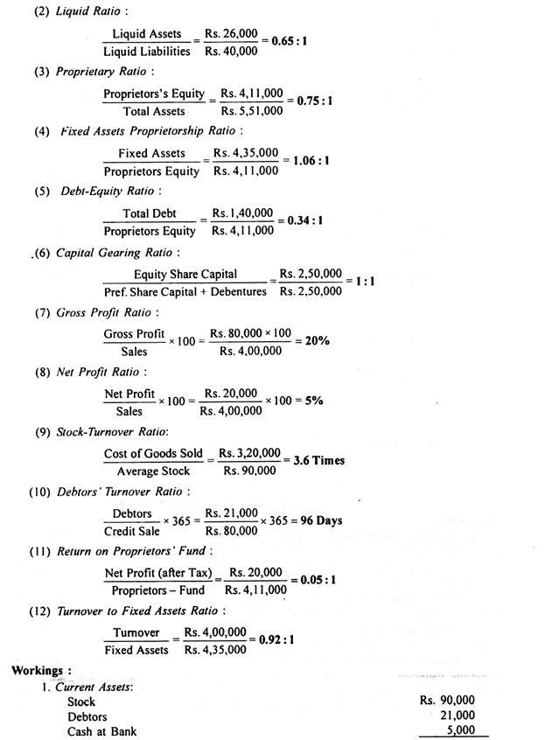](http://cdn.accountingnotes.net/wp-content/uploads/2017/01/clip_image027.jpg)**

**[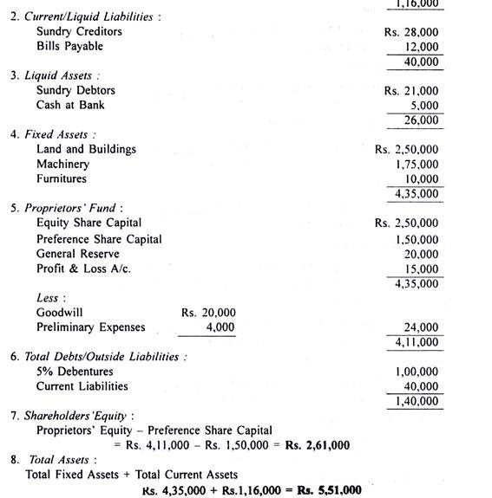](http://cdn.accountingnotes.net/wp-content/uploads/2017/01/clip_image028-1.jpg)**

**Comments:**